Student Name: Bhavya UID: 24BAI70791
Branch: CSE(AI & ML) Section/Group: 24AIT_KRG-1/G2
Semester: 4 Date of Performance: 13/01/2026
Subject Name: Database Management System Subject Code: 24CSH-298

Experiment 1

Aim
To design and implement a Library Management System database using PostgreSQL that stores information about books, members, and issue records, and to apply role-based access control using SQL commands.

Software Requirements
- PostgreSQL/pgAdmin
- MSWord

Objective
- To create tables for Books, Members, and Issue Records.
- To perform INSERT, SELECT, UPDATE, and DELETE operations.
- To apply Primary Key, Foreign Key, and CHECK constraints.
- To create a librarian role and assign permissions.
- To understand database security using GRANT and REVOKE commands.

Practical / Experiment Steps
- Start the system and log in to PostgreSQL.
- Create the required tables for the library database.
- Insert records into the tables.
- Perform SELECT, UPDATE, and DELETE operations.
- Create a role named librarian2.
- Grant SELECT, INSERT, and DELETE permissions to the librarian2.
- Revoke DELETE permission on Books table.
- Login as librarian2 and test access permissions.
- Verify output after execution.
- Save the work and take screenshots.

Practical / Experiment Steps
(A) Database Creation and Operations

SELECT CURRENT_USER;

CREATE TABLE Books (
Book_id INT PRIMARY KEY,
Book_name VARCHAR(50) NOT NULL,
author VARCHAR(50),
available_copies INT CHECK (available_copies >= 0)
);
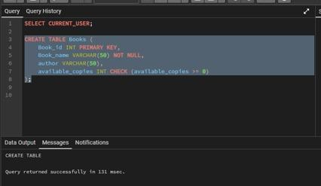
CREATE TABLE members (
member_id INT PRIMARY KEY,
member_name VARCHAR(50) NOT NULL,
email VARCHAR(50) UNIQUE
);
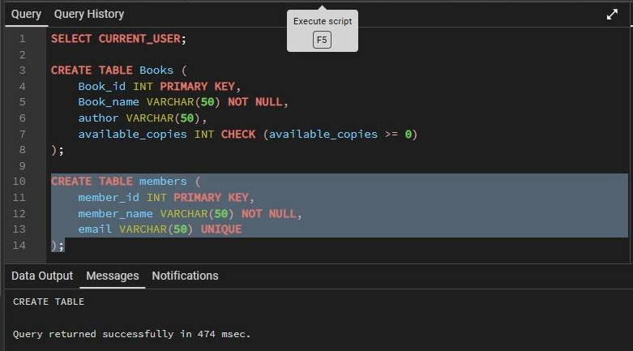

CREATE TABLE issue_records (
issue_id INT PRIMARY KEY,
book_id INT REFERENCES books(book_id),
member_id INT REFERENCES members(member_id),
issue_date DATE NOT NULL
);
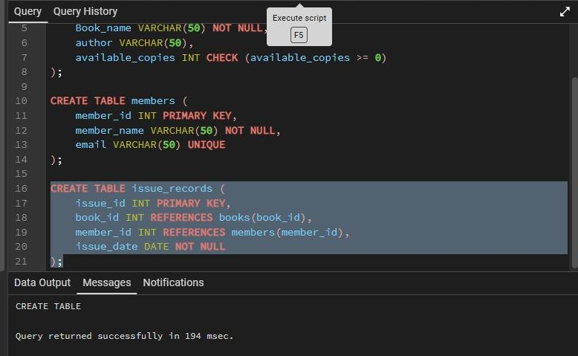

INSERT INTO books VALUES (1, 'DBMS', 'Korth', 5);
INSERT INTO books VALUES (2, 'Operating Systems', 'Silberschatz', 3);

INSERT INTO members VALUES (101, 'Bhavya', 'bhavya@gmail.com');
INSERT INTO members VALUES (102, 'Akash', 'akash@gmail.com');

INSERT INTO issue_records VALUES (1001, 1, 101, '2025-01-15');
INSERT INTO issue_records VALUES (1002, 2, 102, '2025-06-15');
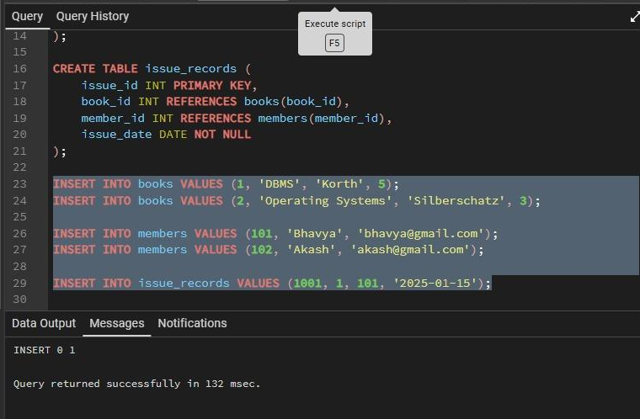

SELECT book_name
FROM books
WHERE book_id = 1;
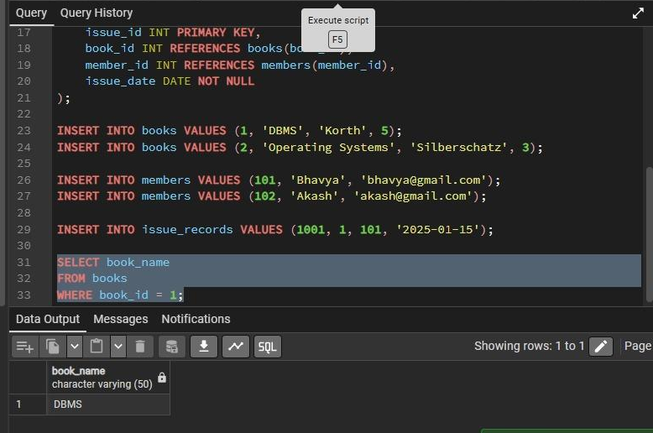

UPDATE books
SET available_copies = 4
WHERE book_id = 1;
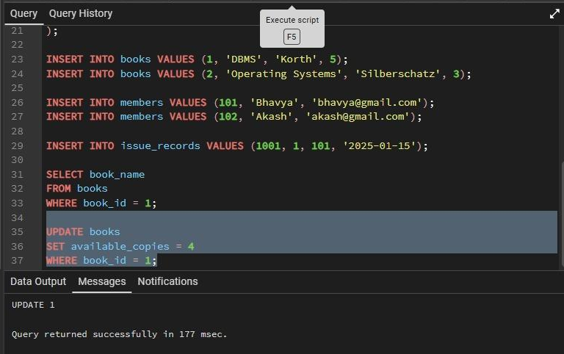
DELETE FROM issue_records
WHERE issue_id = 1001;

SELECT * FROM books;
SELECT * FROM members;
SELECT * FROM issue_records;
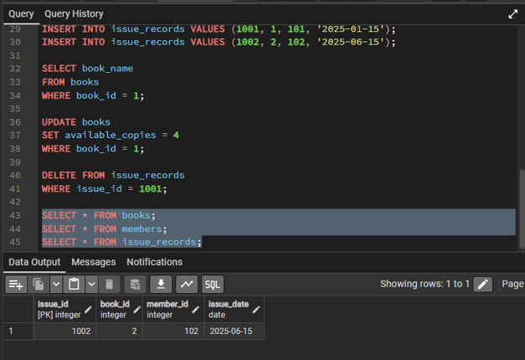

(B) Role Creation and Privileges

CREATE ROLE librarian2 WITH LOGIN PASSWORD 'lib123';

GRANT SELECT, INSERT, DELETE ON books TO librarian2;
GRANT SELECT, INSERT, DELETE ON members TO librarian2;
GRANT SELECT, INSERT, DELETE ON issue_records TO librarian2;

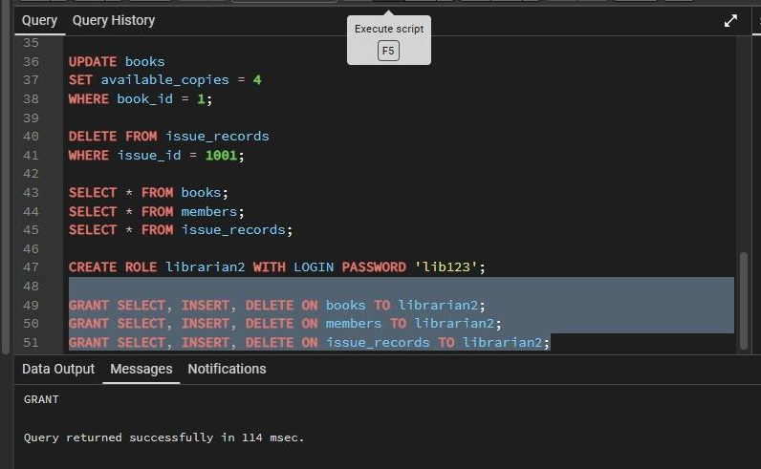

REVOKE DELETE ON books FROM librarian2;

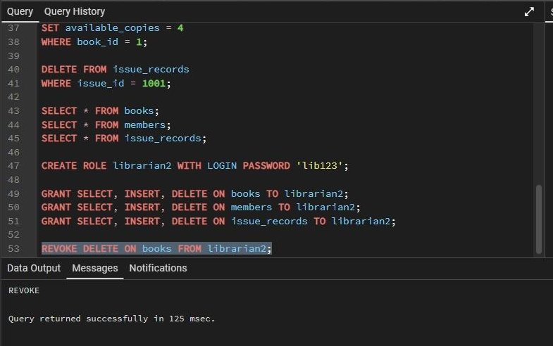

(C) Librarian Access Operations

SELECT * FROM books;
SELECT * FROM members;
SELECT * FROM issue_records;
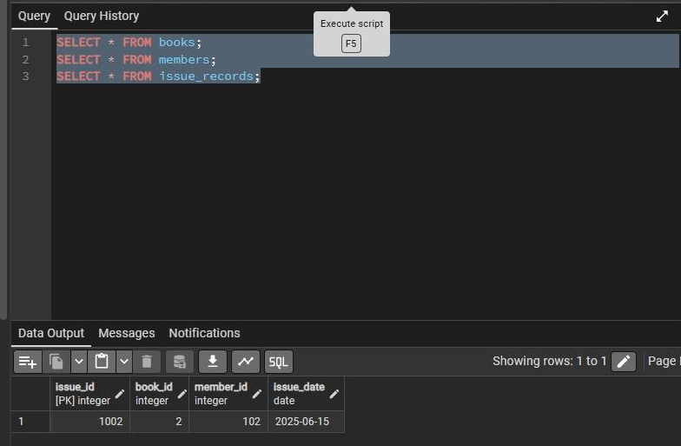
INSERT INTO members VALUES (103, 'Avneet', 'avi@gmail.com');
INSERT INTO issue_records VALUES (1003, 1, 101, '2026-01-06');
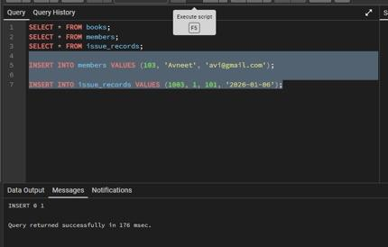

DELETE FROM issue_records WHERE issue_id = 1002;
DELETE FROM books WHERE book_id = 1;
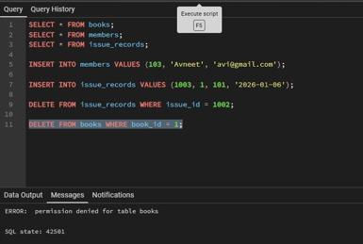

Input/Output Details

Input:
- Book ID, Book Name, Author, Available Copies
- Member ID, Member Name, Email
- Issue ID, Book ID, Member ID, Issue Date

Output:
- Tables created successfully
- Records inserted into tables
- Book details retrieved using SELECT
- Available copies updated
- Issue record deleted
- Role created and permissions assigned

Learning Outcome
- Learned to design relational tables using primary and foreign keys.
- Understood the use of constraints to maintain data integrity.
- Gained knowledge of CRUD operations in SQL.
- Learned how to create and manage user roles.
- Understood database security using GRANT and REVOKE commands.
- Acquired practical exposure to Library Management System database design.

